**Chapter 7: Electrochemistry**

**All Lectures Uploaded on YouTube:**

[**https://tinyurl.com/fkm9-chemistry**](https://tinyurl.com/fkm9-chemistry)

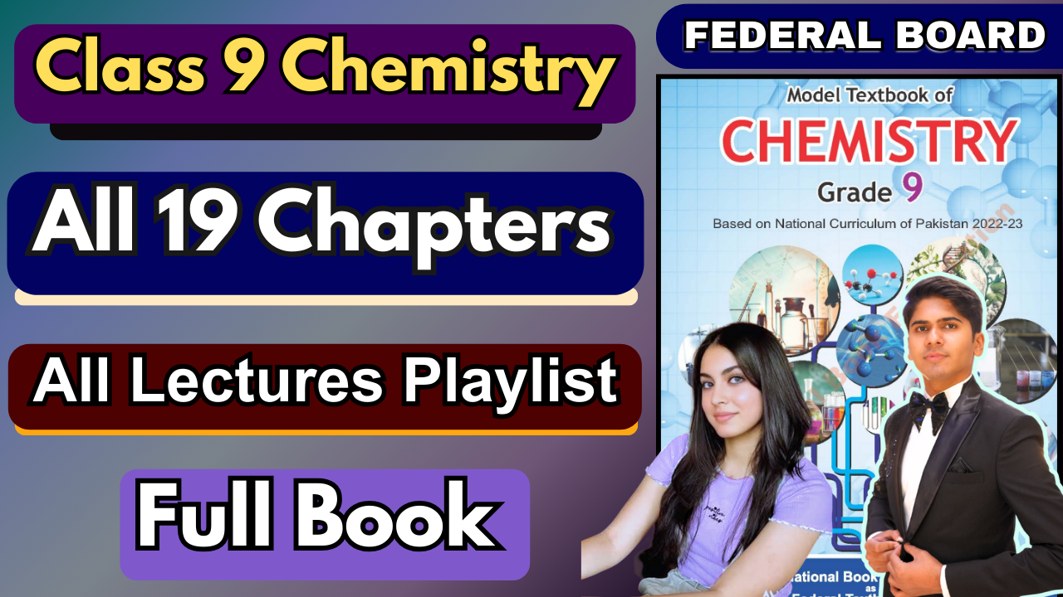

**Redox reactions** are fundamental chemical processes involved in many natural and industrial activities.

**Examples in daily life:**

o **Rusting** of iron objects.

o **Burning** of fuel in car engines and forest fires.

o **Metabolism** of food in our bodies.

**Industrial Importance:**

o Production of electricity in **batteries and fuel cells**.

o Decolorizing substances with **household bleaches**.

o Industrial production of metals and chemicals.

**7.1. OXIDATION AND REDUCTION (REDOX)**

Oxidation and reduction always occur **simultaneously** in a reaction. Such reactions are called **redox reactions**.

They can be defined in three ways:

1. Transfer of **Oxygen**

2. Transfer of **Hydrogen**

3. Transfer of **Electrons**

**In Terms of Transfer of OXYGEN**

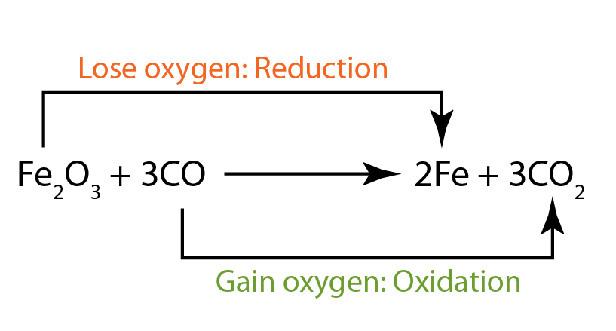

∙ **Oxidation = Gain of Oxygen**

∙ **Reduction = Loss of Oxygen**

**Example from Industry: Extraction of Iron**

Reaction: **Fe₂O₃ + 3CO → 2Fe + 3CO₂**

o **Carbon Monoxide (CO)** gains oxygen to become **CO₂**. So, **CO is oxidized**. o **Iron Oxide (Fe₂O₃)** loses oxygen to become **Fe**. So, **Fe₂O₃ is reduced**.

**In Terms of Transfer of HYDROGEN**

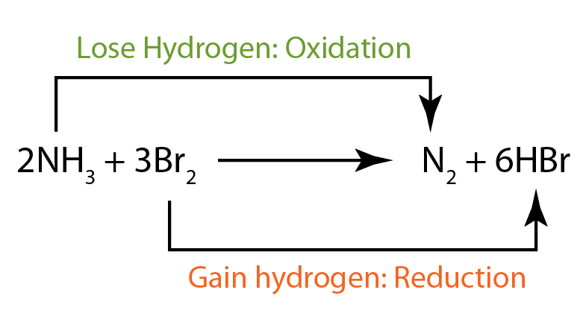

∙ **Oxidation = Loss of Hydrogen**

∙ **Reduction = Gain of Hydrogen**

**Example: Combustion of Acetylene (for welding)**

Reaction: **2C₂H₂ + 5O₂ → 4CO₂ + 2H₂O**

o **Acetylene (C₂H₂)** loses all its hydrogen atoms. So, **C₂H₂ is oxidized**. o **Oxygen (O₂)** gains hydrogen atoms to form water **(H₂O)**. So, **O₂ is reduced**.

**Another Example: Burning of Sui Gas (Methane)**

Reaction: **CH₄ + 2O₂ → CO₂ + 2H₂O**

o **Carbon (C)** in CH₄ loses hydrogen atoms and gains oxygen atoms. So, it is **oxidized**. o **Oxygen (O₂)** gains hydrogen atoms. So, it is **reduced**.

**In Terms of Transfer of ELECTRONS**

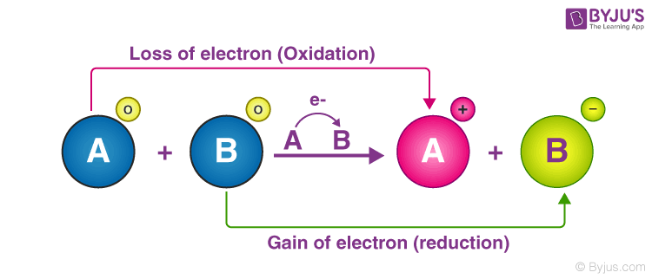

∙ **Oxidation = Loss of Electrons**

∙ **Reduction = Gain of Electrons**

**Example: Reaction between Copper Oxide and Zinc**

Molecular Equation: **CuO + Zn → Cu + ZnO**

**Ionic Equation:** Rewriting to show the ions:

o Cu²⁺ + O²⁻ + Zn → Cu + Zn²⁺ + O²⁻

**Net Ionic Equation:** Remove the spectator ion (O²⁻, which doesn't change).

o **Cu²⁺ + Zn → Cu + Zn²⁺**

**Zinc (Zn):**

o Loses 2 electrons to form Zn²⁺.

o **Oxidation state** changes from **0 to +2** (increase).

o So, **Zn is oxidized**.

**Copper ion (Cu²⁺):**

o Gains 2 electrons to form Cu metal.

o **Oxidation state** changes from **+2 to 0** (decrease).

o So, **Cu²⁺ is reduced**.

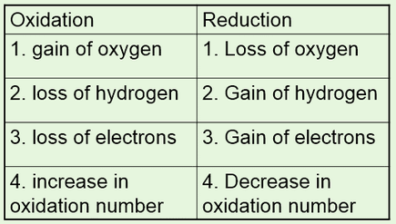

**7.2. OXIDATION STATES AND RULES FOR ASSIGNING OXIDATION STATES**

**7.2.1. Oxidation States (Oxidation Numbers)**

**Definition:** The oxidation state or oxidation number is the **hypothetical charge** an atom would have if all its bonds in a molecule or compound were 100% ionic (as if electrons were completely transferred).

**Primary Use:** It is the most reliable method for identifying oxidation and reduction in a reaction.

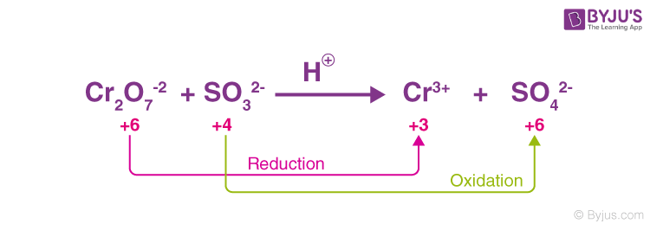

o **An increase in oxidation number = Oxidation**

o **A decrease in oxidation number = Reduction**

**Summary Table of Redox Processes:**

| **Oxidation** | **Reduction** |
| --- | --- |
| Gain of Oxygen | Loss of Oxygen |
| Loss of Hydrogen | Gain of Hydrogen |
| Loss of Electrons | Gain of Electrons |

**7.2.2. Rules for Assigning Oxidation States/Numbers**

To assign oxidation numbers correctly, you must follow a set of official rules. **The Main Rules:**

1. **Free Elements:** The oxidation state of any pure, uncombined element is always **0**.

*Examples:* Zn (metal), Na (metal), O₂ (gas), H₂ (gas), S₈ (solid). In all these, each atom has an oxidation number of **0**.

2. **Simple Ions:** The oxidation state of a simple ion is equal to its **ionic charge**. *Examples:* In Na⁺, the oxidation number is **+1**. In Ca²⁺, it is **+2**. In Cl⁻, it is **-1**.

3. **Complex/Polyatomic Ions:** The sum of the oxidation numbers of all the atoms in a polyatomic ion must equal the **charge on the ion**.

*Example:* In the carbonate ion, CO₃²⁻, the sum of the oxidation numbers of one C atom and three O atoms must equal **-2**.

4. **Neutral Compounds:** The sum of the oxidation numbers of all the atoms in a neutral molecule is **0**.

*Example:* In HCl, the sum of the oxidation numbers of H and Cl is **0**. In CO₂, the sum of one C and two O atoms is **0**.

**Common, Fixed Oxidation States (Memorize these!):**

* Element / Group Typical Oxidation State Important Exceptions Group 1 (IA) **+1** Always
* Group 2 (IIA) **+2** Always
* Hydrogen (H) **+1 -1** in metal hydrides (e.g., NaH)
* Oxygen (O) **-2 -1** in peroxides (e.g., H₂O₂), **+2** in OF₂ Group 17
* (VIIA) **-1** Always in binary compounds

**Applying the Rules: Monatomic vs. Polyatomic Ions** 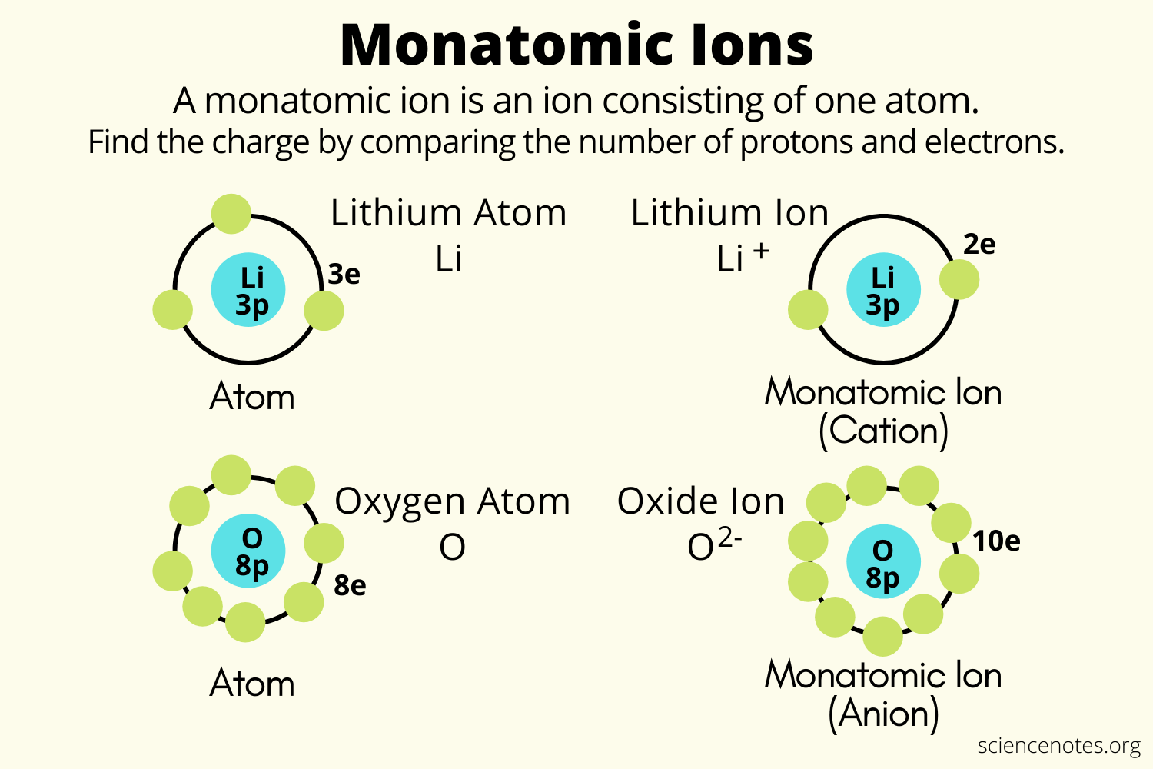

∙ **Monatomic Ions:** A single atom with a charge.

Its oxidation number **is** its charge.

*Example:* A sodium **atom** (Na) has an oxidation number of 0. A sodium **ion** (Na⁺) has an oxidation number of **+1**. A chloride **ion** (Cl⁻) has an oxidation number of **-1**.

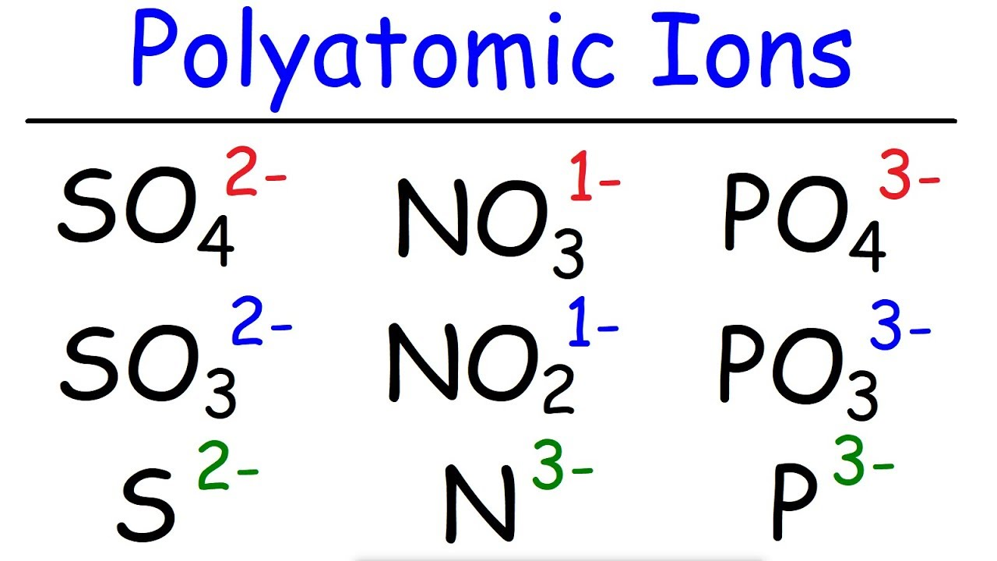

∙ **Polyatomic Ions:** A group of atoms with a collective charge.

The **sum** of all oxidation numbers in the ion equals the ion's charge.

*Example:* **Carbonate Ion (CO₃²⁻)**

Overall Charge = **-2**

Oxygen's oxidation state = **-2** (Rule: Common State)

**7.3. FORMULA OF AN IONIC COMPOUND**

**Key Principle:** All ionic compounds are **electrically neutral**. This means the **total positive charge** from the cations must exactly balance the **total negative charge** from the anions.

To write a correct formula, follow these three steps:

**Step 1: Identify the Ions and Their Charges.**

∙ Figure out what the positive ions (cation) and negative ions (anion) are, and know their charges (e.g., from the periodic table or from a polyatomic ion chart).

**Step 2: Determine the Ratio for Neutrality.**

∙ Find the simplest whole-number ratio of cations to anions that makes the total charge zero.

**Step 3: Write the Formula.**

∙ Write the cation first, then the anion.

∙ Use subscripts to show the ratio determined in Step 2.

∙ **Crucial Rule:** If a polyatomic ion needs a subscript greater than 1, you **must put it in parentheses**.

**Worked Examples:**

**Example 1: Calcium Chloride**

1. **Ions & Charges:** Ca²⁺ and Cl⁻

2. **Ratio:** One +2 charge needs two -1 charges to cancel out. Ratio is **1 Ca²⁺ to 2 Cl⁻**. 3. **Formula: CaCl₂**

**Example 2: Magnesium Oxide**

1. **Ions & Charges:** Mg²⁺ and O²⁻

2. **Ratio:** One +2 charge balances one -2 charge. Ratio is **1:1**.

3. **Formula: MgO**

**Example 3: Aluminum Sulfate**

1. **Ions & Charges:** Al³⁺ and SO₄²⁻

2. **Ratio:**

Total positive charge needed: +6 (LCM of 3 and 2).

Number of Al³⁺ ions: 2 (2 × +3 = +6)

Number of SO₄²⁻ ions: 3 (3 × -2 = -6)

Ratio is **2 Al³⁺ to 3 SO₄²⁻**.

3. **Formula:** Since we need more than one sulfate ion, we use parentheses: **Al₂(SO₄)₃**

**7.3.1. Use of Roman Numerals as Oxidation Number**

**Why?** Some metals, especially **transition metals** (like Iron, Copper), can form ions with **different charges**.

**Purpose:** Roman numerals in a compound's name explicitly state the **oxidation state** (charge) of the metal ion. This avoids confusion.

**Examples:**

o **CuSO₄:** Copper can be +1 or +2. In this compound, it's +2. So, the name is **Copper(II) sulphate**.

o **FeCl₂:** The iron ion has a +2 charge. Name: **Iron(II) chloride**.

o **FeCl₃:** The iron ion has a +3 charge. Name: **Iron(III) chloride**.

**7.4. OXIDIZING AND REDUCING AGENTS**

**Definitions:**

**Oxidizing Agent (Oxidant):**

o A substance that **accepts electrons** from another substance.

o It **causes oxidation** to happen to another substance.

o **Itself, it is REDUCED.**

o *Common Examples:* Oxygen (O₂), Chlorine (Cl₂), Hydrogen Peroxide (H₂O₂), Potassium Permanganate (KMnO₄).

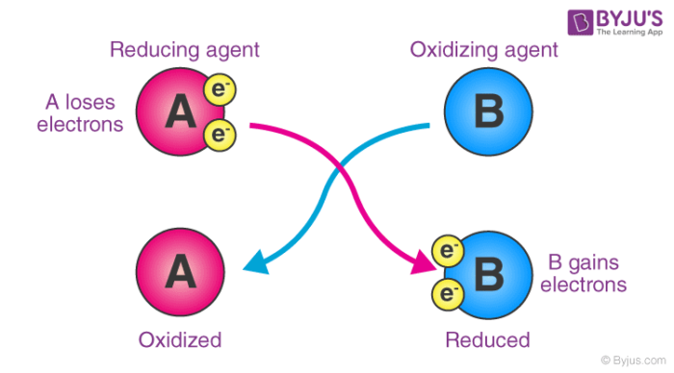

**Reducing Agent (Reductant):**

o A substance that **donates electrons** to another substance.

o It **causes reduction** to happen to another substance.

o **Itself, it is OXIDIZED.**

o *Common Examples:* Hydrogen Gas (H₂), Reactive Metals (Zn, Al), Carbon Monoxide (CO).

**Simple Rule: OIL RIG** for agents:

∙ **Oxidizing Agent** Is **Reduced** (and gains electrons).

∙ **Reducing Agent** Is **Oxidized** (and loses electrons).

**Example Reaction:** 2Na + Cl₂ → 2NaCl

∙ Sodium (Na) is oxidized (loses an electron). Therefore, **Na is the Reducing Agent**. ∙ Chlorine (Cl₂) is reduced (gains an electron). Therefore, **Cl₂ is the Oxidizing Agent**.

**7.4.2. How to Identify Oxidizing and Reducing Agents?**

The most reliable method is to track changes in **oxidation numbers**.

**Example Reaction from Steel Manufacturing:**

Fe₂O₃ + 3CO → 2Fe + 3CO₂

1. **Assign Oxidation Numbers:**

*In Fe₂O₃:* O is -2, so Fe must be **+3**.

*In CO:* O is -2, so C must be **+2**.

*In Fe:* Pure element, so Fe is **0**.

*In CO₂:* O is -2, so C must be **+4**.

2. **Identify Oxidation and Reduction:**

**Carbon (C):** Changes from **+2** in CO to **+4** in CO₂. (Increase = **Oxidation**) **Iron (Fe):** Changes from **+3** in Fe₂O₃ to **0** in Fe. (Decrease = **Reduction**

3. **Identify the Agents:**

The substance that **contains the atom being oxidized** is the **Reducing Agent**. Here, **CO** contains the carbon that is oxidized, so **CO is the Reducing Agent**.

The substance that **contains the atom being reduced** is the **Oxidizing Agent**. Here, **Fe₂O₃** contains the iron that is reduced, so **Fe₂O₃ is the Oxidizing Agent**.

**7.5. CORROSION AND ITS PREVENTION**

**7.5.1. Corrosion**

Corrosion is a **natural electrochemical process** where a metal reacts with its environment (especially oxygen and moisture) and gets converted into a more stable compound, usually an oxide.

**The Common Example:** The **rusting of iron** is the most familiar form of corrosion. **Essential Requirements for Rusting: Oxygen** and **Water** are both necessary.

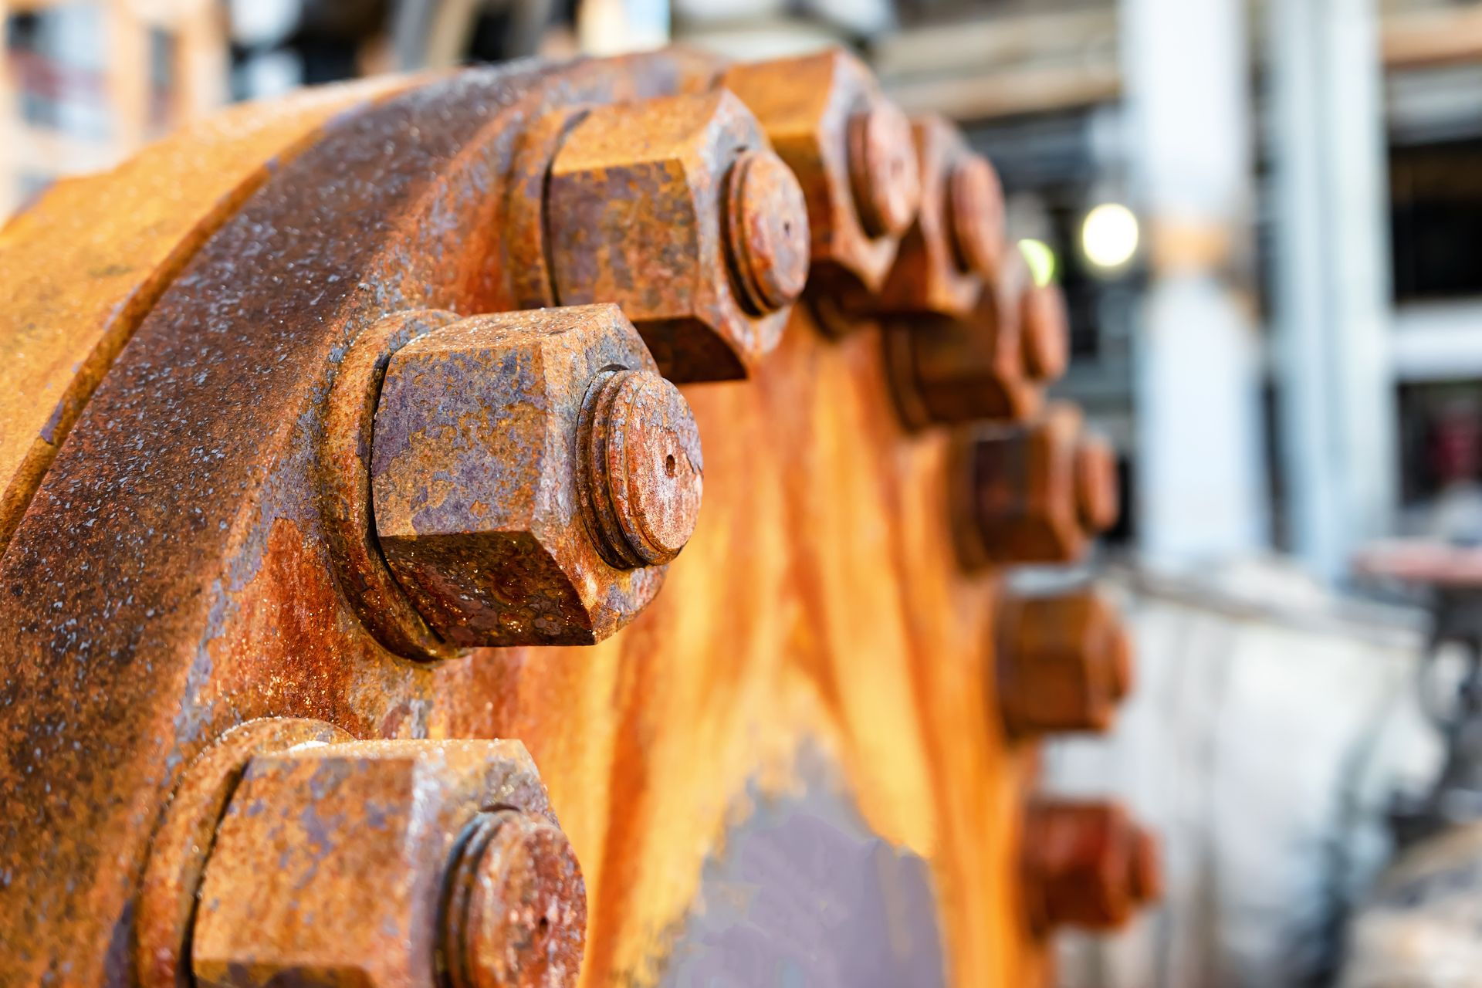

**The Electrochemistry of Rusting (How it works):**

Rusting is a redox reaction that sets up a tiny **electrochemical cell** on the surface of the iron.

1. **Anode (Site of Oxidation - Less Moist Area):**

Here, iron metal **loses electrons** and is oxidized.

**Reaction:** Fe(s) → Fe²⁺(aq) + 2e⁻

2. **Cathode (Site of Reduction - More Moist Area):**

The electrons released at the anode travel to this area.

Here, atmospheric oxygen **gains those electrons** and is reduced.

**Reaction:** O₂ + 2H₂O + 4e⁻ → 4OH⁻

3. **Formation of Rust:**

The Fe²⁺ ions (from the anode) and OH⁻ ions (from the cathode) meet in the water film.

They react to form ferrous hydroxide, which is then further oxidized by oxygen to form **rust**, a hydrated iron(III) oxide with the formula **Fe₂O₃·xH₂O**.

**7.5.2. Prevention of Corrosion**

Preventing corrosion is crucial to protect infrastructure, vehicles, and equipment, and to conserve metal resources. Here are the main methods:

**1. Coating with Paint or Epoxy:**

∙ **How it works:** Creates a simple **physical barrier** that prevents oxygen and moisture from reaching the metal surface.

∙ **Use:** Very common and cost-effective. Used on cars, bridges, ships, and many other steel structures. It also improves appearance.

**2. Alloying:**

∙ **How it works:** Mixing the base metal with other elements to create a new material with superior corrosion resistance.

∙ **Example: Stainless Steel.** Adding **Chromium** to iron makes stainless steel. Chromium forms a tough, invisible oxide layer that protects the iron underneath from further attack.

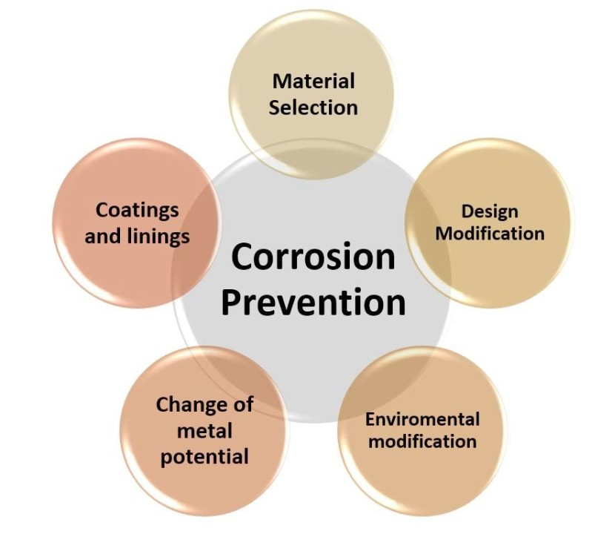

**3. Coating with a Thin Layer of Another Metal:**

This method provides a protective metal layer. The protection mechanism depends on the metal used:

**(a) Tinning:**

o **Process:** Coating iron with a layer of **tin** (Sn).

o **Protection Mechanism:** Tin is **less reactive** and provides a **physical barrier**. It is non toxic, which is why it's used for **food cans**.

o **Drawback:** If the tin coating is scratched, the iron underneath will corrode *faster* because tin is less active.

**(b) Galvanizing:**

o **Process:** Coating iron with a layer of **zinc** (Zn).

o **Protection Mechanism:** Zinc provides a barrier AND acts as a **sacrificial anode**. Even if the coating is scratched, the more reactive zinc will corrode *instead* of the iron. This is why galvanized steel is used for roofing, nails, and fences.

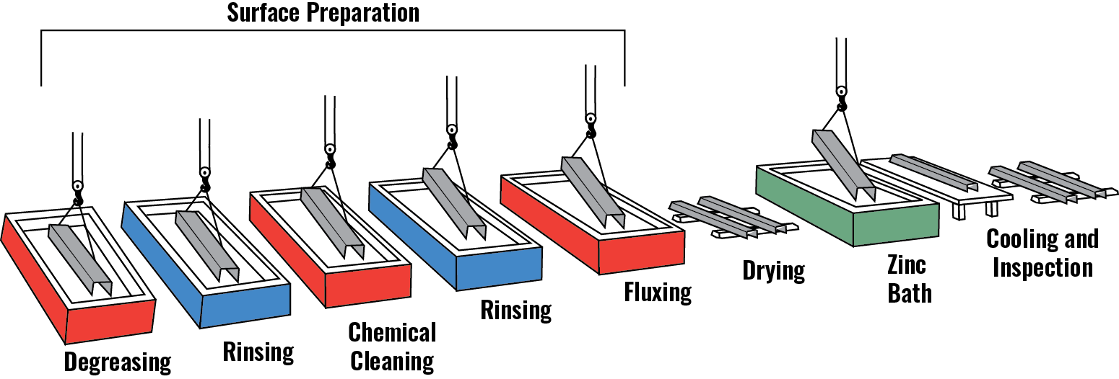

**(c) Electroplating:** 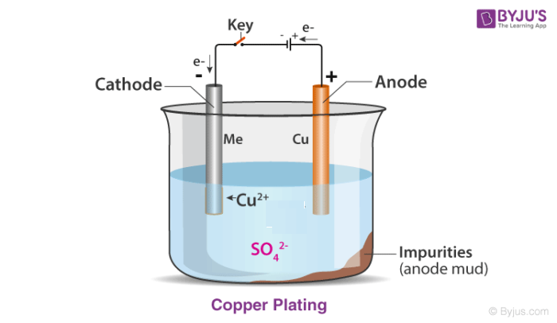

o **Process:** Using electricity to deposit a thin, decorative, and protective layer of a metal (like chromium or nickel) onto the surface of another metal.

**4. Cathodic Protection (Sacrificial Protection):**

**How it works:** This method forces the iron structure to become the **cathode** in an electrochemical cell, thus preventing it from oxidizing.

**Process:** A block of a **more reactive metal** (like **Magnesium** or **Zinc**) is connected electrically to the iron structure. This block acts as the **sacrificial anode**. 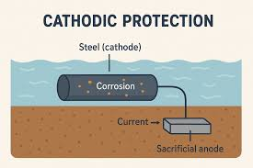

o The more active metal (Mg/Zn) willingly **oxidizes** and corrodes.

o It supplies electrons to the iron, forcing the iron to be the cathode where reduction (of oxygen) occurs.

o The iron is saved while the sacrificial anode is "sacrificed" and needs to be replaced periodically.

**Use:** Ideal for large, buried, or submerged structures like **underground pipelines, ship hulls, and water tanks**. The diagram shows magnesium blocks attached to a ship's hull for this purpose.



